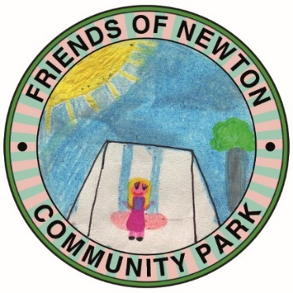
July 2021 Update

M O R E F A N T A S T I C N E W S

Phase 1 Park renovation contract agreed!

Funding
Since our last update in March when we announced we had already exceeded our funding target. We have been granted a further £1,290 for the Sensory Garden thanks to Fylde Borough Council and the National Lottery Community Fund.

Sensory Garden

Hopefully you will all have seen the fabulous planters made for us by Dig In – a charity that provides support to Armed Forces and Blue Light Veterans. Each planter around the circle is planted to focus on a particular sense with the central planter labelled Sensory Garden 2021. Benches are on order for between the planters. Behind the circle we intend to gradually create a nature area and will be installing bug boxes and bird boxes with a path through the area for children to explore. The outside of the circle will become a shrub and flower border and the path to the millennium circle will be lined with scented plants to create an entrance through the willow arch. We hope this will become a relaxing place for everyone to enjoy as the year progresses.

Play Park

We are delighted to say that the tender process has been completed and Kompan have been confirmed as the contractor to deliver the renovation of the Play Park. The schedule of work has not yet been finalised but it is likely that it will begin in September 2021 and run for approximately 3 months.
You will see from the “mockup” picture of the site that this is set to become a great place for our children to play and includes
- Zip wire, trampoline, climbing castle with slide and balance swing.
- Fencing to the existing tarmac surface to create a Multi Use Games Area including football goals, basketball rings and line markings.
Exact location of the equipment may be subject to minor change.
We will update you further once the schedule is confirmed.

Email : friendsofnewtoncommunitypark@gmail.com
FaceBook : Friends of Newton Community Park
